Assignment - Schwartz Style Masdar critique

Points: 60
Submitting: a text entry box, a website url, or a file upload

Rubric
Criteria | Ratings |  |  |  |  |  | Pts
Step 1. Group formed. | 10.0 pts  Full Marks |  |  | 0.0 pts  No Marks |  |  | 10.0 Pts
Step 2. Synthesis questions in matrix. | 30.0 pts  Excellent representation of content in article organized in clusters on whiteboard. | 27.0 pts  Quite good representation of content in article represented in photograph of whiteboard. | 23.0 pts  Good representation of content in article represented in photograph of whiteboard. | 15.0 pts  Ok representation of content in article represented in photograph of whiteboard. | 0.0 pts  No Marks |  | 30.0 Pts
Step 3. Synthesis questions in matrix. | 20.0 pts  Excellent answers to at least half of the matrix questions. | 18.0 pts  Quite good insights to some matrix questions | 17.0 pts  Good insights to some matrix questions | 15.0 pts  Some insights to matrix questions. | 10.0 pts  Hard to follow logic of comments in matrix. | 0.0 pts  No Marks | 20.0 Pts
Total Points: 60

LOs
- Critically analyze Masdar according Peter Schwartz perspective on why people are surprised by events.
- Create a map that articulates your assumptions about futures based on STEEP forces.
- Articulate what worldviews are embedded within your assumptions about the futures.
Part 2 Thursday
- Speculate on whom the intended audience was for Masdar.
- Articulate who is the intended audience for your previous Masdar concepts.

According to Peter Schwartz some challenges designers face include:
- People have their own worldviews and once you believe your own mental map the harder it is to change it.
- Past successes achieved with good mental maps does not predict future success.
- Challenging our mental maps is an uncomfortable process, but critical for thinking broadly and for asking the right kinds of questions.

Below is the “Island of California” Map that Peter Schwartz mentions in one of his videos you viewed in the OLI homework.
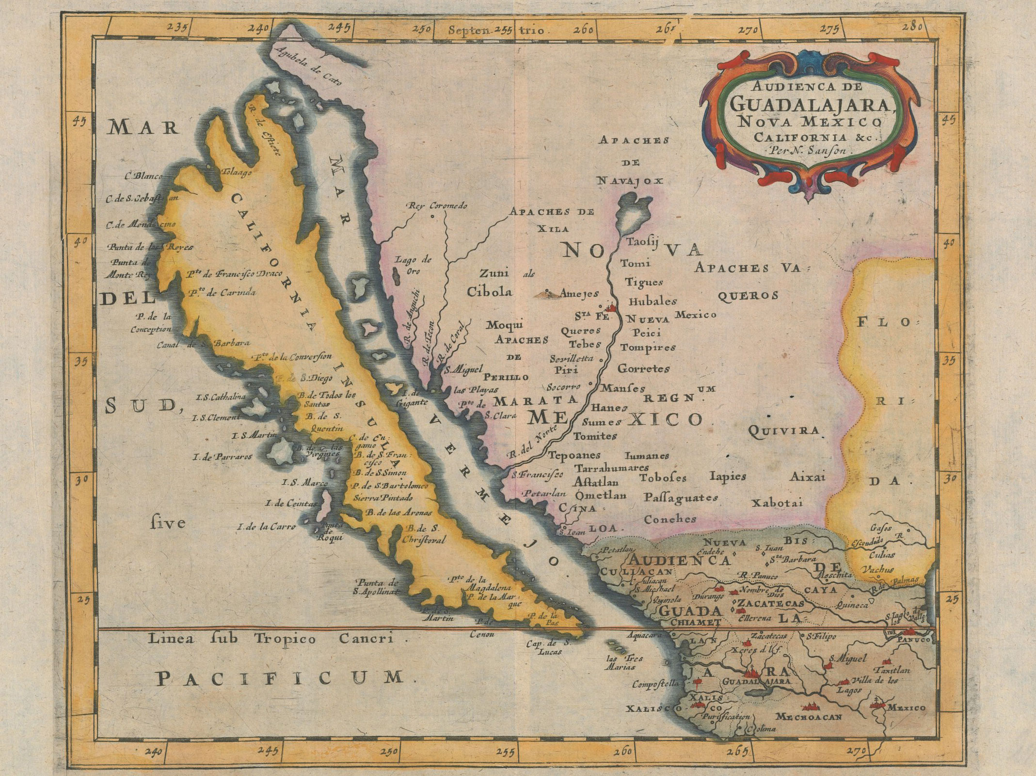

It is is obvious now that California is not an island, but back in the 1700’s when people had to draw maps by hand of areas they visited, it was not. Map makers filled in the missing data with what seemed like reasonable guesses.

It is easy to laugh at such silly mistakes, but we use the same mental shortcuts when we make reasonable guesses based on the available information to inform design decisions. And one definition of design according to Joep Frens is “making decisions without enough information.”

What could the mapmakers have done differently? Perhaps shown where the data was, and referencing the sources, and showing where the speculations are.

So we are going to practice unpacking assumptions from the maps of Masdar.Let's get back to the “maps” or assumptions that lead to the design of Masdar City. You’ll be asked to extrapolate from published accounts. Below is a critique of Luis Bettecourt that gets at some of the assumptions of Masdar.

http://www.livemint.com/Politics/k1CagCp3wad3ousVlX3cAP/The-city-is-not-a-massive-machine-says-Luis-Bettencourt.html

“What do you think of smart cities?
It’s kind of interesting because at some level it’s really a model of total planning from an engineer’s perspective. Everything will be made automatic, all the transportation, water systems, sanitation, all the energy is renewable, more efficient systems, that creates maybe more sustainable cities, but it’s kind of unnatural from the point of view of cities. The city is not a massive machine.
For example, Masdar City is a totally engineered, green city development in the United Arab Emirates but essentially it’s an office park, it’s not a real city. And a lot of it was phased down. It’s not going to happen. So a lot of what happens quickly with these visions of the engineered city is that it becomes this bureaucratic nightmare where somebody is in charge and controlling everybody else, so that’s again not the nature of the city and it’s counterproductive, is probably ethically wrong in many ways.”

First read the
Post-it notes might be: Questions you might have include:
- Engineering centric total planning (what are other approaches?)
- City as machine central planning (what are other planning processes?)
- Office park not real city (what is the difference between city & parts?)
- Unnatural approach to city (what might be more natural approaches?)

In this assignment, you will get practice extracting your assumptions about the revised Masdar scenarios and concepts you developed.

Step 1. Count off into 5 groups and physically meet-up (5 minutes)
Groups 1: http://www.economist.com/node/12673433

Groups 2: https://www.theguardian.com/environment/2016/feb/16/masdars-zero-carbon-dream-could-become-worlds-first-green-ghost-town

Groups 3:
http://www.cnn.com/style/article/conversation-masdar-city-lee/index.html

Groups 4:
https://www.theguardian.com/environment/2011/apr/26/masdar-city-desert-future

Groups 5:
https://www.bloomberg.com/news/articles/2011-12-08/masdar-city-castle-in-the-sand

Self-organize into sub-groups of 3-4 people.
What are your names?
What article did you read?

Step 2. (15 minutes)
Read Masdar articles. Write on post-it notes one idea, post on whiteboard. Cluster similar ideas. Give each cluster a name with a whiteboard marker.
Observe the intent for Masdar, and what really happened in Masdar.
(Insert a picture of your post-its clustered on the whiteboard).

Step 3. (20 minutes) Synthesize your insights.
Looking at your post-it note clusters discuss with your classmates answer the following questions. Answer the questions that map to the reading you had.

 | In the plans for Masdar? | What do you think was good about this? | What is missing or what questions might you have?
What “maps” or assumptions first guided the Masdar plan?
What mental models of the world are at play then?
What worldviews were embedded in the Masdar concept?
What forces might have shifted between 2006 and 2017 in Masdar (e.g., metaphorically tides, wind, currents) more practically STEEP assumptions?
What might be some alternative models of the world (e.g., maps of the world) that you might want consider now?

Step 4. (15 Minutes)
(2) Based on the Schwartz critiques of your maps, assumptions, forces of change, and worldview of your Masdar scenario, what changes would you have to make to one of your storyboards and Masdar design concepts to avoid such pitfalls?

______________________________________________________________________________

______________________________________________________________________________

