Reflective Judgement and Stages of Development
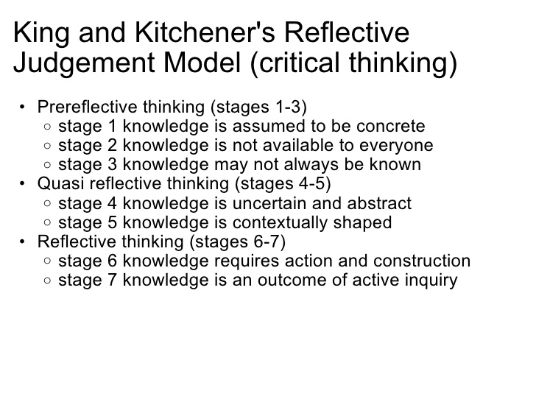
Reflective Judgement Introduction king_kitchener_reflectiveJudgement_1994.pdf
Chapter 3 Seven Stages of Reflective Judgement king_kitchener_chp3_reflectiveJudgement_1994.pdf

William Perry

Forms of Ethical and Intellectual Development in the College Years: A Scheme
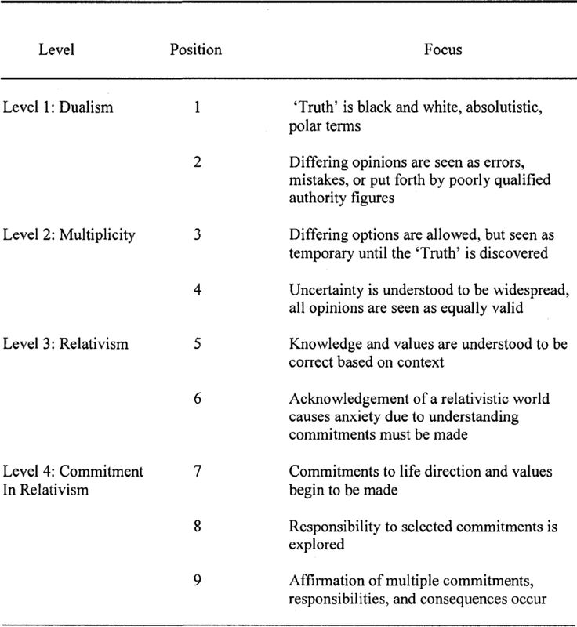
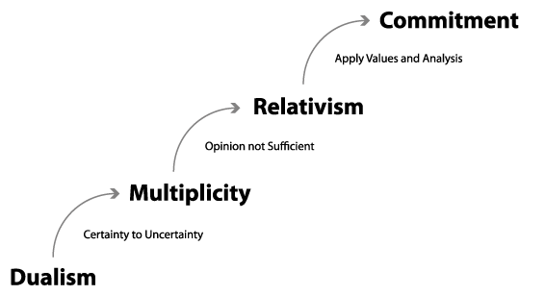
https://en.wikipedia.org/wiki/William_G._Perry

