Futures Cone
https://thevoroscope.com/2017/02/24/the-futures-cone-use-and-history/ (Links to an external site.)

The Futures Cone, use and history
From time to time people ask me about the Futures Cone (Links to an external site.), and how it came about. Let me give a brief history of how I came across it before adapting it to suit my use of the concept. I first began using an early version of the Futures Cone diagram (i.e., with fewer categories) in 2000 when working as a foresight analyst for Swinburne University (before becoming an academic in the Master of Strategic Foresight). The text in this post is excerpted from a chapter I submitted to the Handbook of Anticipation, ed. Roberto Poli (Springer International). The “formal” citation for the chapter/book is:
Voros, J 2017, ‘Big History and anticipation: Using Big History as a framework for global foresight’, in R Poli (ed.) Handbook of anticipation: Theoretical and applied aspects of the use of future in decision making, Springer International, Cham. doi:10.1007/978-3-319-31737-3_95-1 (Links to an external site.),
while the text in this post is from the section of that chapter entitled ‘Types of Alternative Futures’, pp. 10-13, and the “cone” diagram itself is: Fig. 4, p. 11.

Futurists have often spoken and continue to speak of three main classes of futures: possible, probable, and preferable (e.g., Amara 1974, 1981; Bell 1997, and many others). These have at times lent themselves to define various forms of more specialised futures activity, with some futurists focusing on, as it were, exploring the possible; some on analysing the probable; and some on shaping the preferable, with many related variations on this nomenclature and phraseology (e.g., again, Amara 1991, and many others). It is possible to expand upon this three-part taxonomy to include at least 7 (or even 8) major types of alternative futures.
It is convenient to depict this expanded taxonomy of alternative futures as a ‘cone’ diagram. The ‘futures cone’ model was used to portray alternative futures by Hancock (Links to an external site.) and Bezold (1994), and was itself based on a taxonomy of futures by Henchey (1978), wherein four main classes of future were discussed (possible, plausible, probable, preferable). Some years later I found out that this idea of a cone graphic was used even earlier than Hancock and Bezold (1994) by Charles Taylor (1990), in which he wrote of a “cone of plausibility” that defined a range of plausible futures extended over an explicit timeframe, including a kind of ‘back-cone’ into the past. He also included “wildcards” in his approach, but other futures categories mentioned here were not explicitly depicted in the diagram given by Taylor as they were by Hancock and Bezold.
Over the years that I have been using the Futures Cone in foresight teaching and practice, I have found it useful to adapt it and add more classes to the initial few. The most recent version of the Futures Cone as I now use it is as depicted in the figure shown.
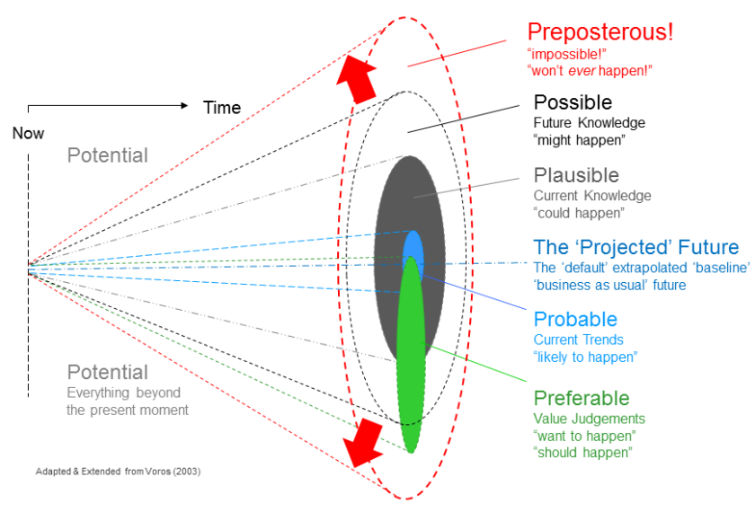
The 7 types of alternative futures defined below (or 8 if one also includes a specific singular ‘predicted’ future, which I generally don’t do any more) are all considered to be subjective judgements about ideas about the future that are based in the present moment, so the categories for the same idea can obviously change over time as time goes on (the canonical example of which is the Apollo XI Moon landing, which has gone through most of the categories from ‘preposterous’ to ‘projected’ and thence into history as ‘the past’). In brief, these categories are:
- Potential – everything beyond the present moment is a potential future. This comes from the assumption that the future is undetermined and ‘open’ not inevitable or ‘fixed’, which is perhaps the foundational axiom of Futures Studies.
- Preposterous – these are the futures we judge to be ‘ridiculous’, ‘impossible’, or that will ‘never’ happen. I introduced this category because the next category (which used to be the edge of the original form of the cone) did not seem big enough, or able to capture the sometimes-vehement refusal to even entertain them that some people would exhibit to some ideas about the future. This category arises from homage to James Dator and his Second Law of the Future—“any useful idea about the future should appear ridiculous” (Dator 2005)—as well as to Arthur C. Clarke and his Second Law—“the only way of finding the limits of the possible is by going beyond them into the impossible” (Clarke 2000, p. 2). Accordingly, the boundary between the Preposterous and the Possible could be reasonably called the ‘Clarke-Dator Boundary’ or perhaps the ‘Clarke-Dator Discontinuity’, since crossing it in the outward direction represents a very important but, for some people, very difficult, movement in prospection thinking. (This is what is represented by the red arrows in the diagram.)
- Possible – these are those futures that we think ‘might’ happen, based on some future knowledge we do not yet possess, but which we might possess someday (e.g., warp drive).
- Plausible – those we think ‘could’ happen based on our current understanding of how the world works (physical laws, social processes, etc).
- Probable – those we think are ‘likely to’ happen, usually based on (in many cases, quantitative) current trends.
- Preferable – those we think ‘should’ or ‘ought to’ happen: normative value judgements as opposed to the mostly cognitive, above. There is also of course the associated converse class—the un-preferred futures—a ‘shadow’ form of anti-normative futures that we think should not happen nor ever be allowed to happen (e.g., global climate change scenarios comes to mind).
- Projected – the (singular) default, business as usual, ‘baseline’, extrapolated ‘continuation of the past through the present’ future. This single future could also be considered as being ‘the most probable’ of the Probable futures. And,
- (Predicted) – the future that someone claims ‘will’ happen. I briefly toyed with using this category for a few years quite some time ago now, but I ended up not using it anymore because it tends to cloud the openness to possibilities (or, more usefully, the ‘preposter-abilities’!) that using the full Futures Cone is intended to engender.
The above descriptions are best considered not as rigidly-separate categories, but rather as nested sets or nested classes of futures, with the progression down through the list moving from the broadest towards more narrow classes, ultimately to a class of one—the ‘projected’. Thus, everyfuture is a potential future, including those we cannot even imagine—these latter are outside the cone, in the ‘dark’ area, as it were. The cone metaphor can be likened to a spotlight or car headlight: bright in the centre and diffusing to darkness at the edge—a nice visual metaphor of the extent of our futures ‘vision’, so to speak. There is a key lesson to the listener when using this metaphor—just because we cannot imagine a future does not mean it cannot happen…
Then there are all of the imaginable ones (i.e., inside the cone), beginning with the sub-class of those that we judge to be unreasonable, (i.e., ridiculous), or impossible—‘preposterous’ in my alliteration— and the further sub-class of those that we judge to be ‘reasonable but which would require knowledge we do not yet possess but which we might possess in the future’ and so ‘might’ happen—‘possible’.
Then there is the sub-class of those that we think are reasonable based on what we currently know, and so ‘could’ happen; thus, ‘plausible’. And so on through the rest: the sub-class of futures based on the playing out of current trends—‘probable’; and finally the default extrapolation of current dynamics—the (single) ‘projected’ future, the only class in the whole schema containing only a single future, although different people will ‘project’ different futures, so it is really a single-member class containing many ‘single’ futures, as it were. The similarly single-member class of ‘predicted’ future, which had a similar underlying rationale—namely, what ‘will’ happen depends a lot on whom you ask—is very rarely used, except to make a specific point.
The class of preferred futures—what ‘should’ or ‘ought to’ happen—can take in any or all of the classes from preposterous to projected, because these futures must be at least imaginable (so inside the cone), and because people’s idea of what they prefer—and how they judge others’ preferences—can range from the default projected future thought to be coming all the way outward to (what is considered) outlandish preposterous-ness.
To this set, one may also add Wildcards—by definition low probability events (sometimes referred to as ‘mini-scenarios’) that would have very large impact if they occurred (Petersen 1997, 1999). Since they are considered ‘low probability’ (i.e., outside the Probable zone), any member of any class of future outside the range of probable futures could be considered by definition a wildcard (although this usage is not common, as the focus tends to be on ‘high impact’ events). Thus, in this view, some wildcards are considered plausible, some possible, some preposterous, and—the scariest of all—some we have not even imagined or dreamed of yet (i.e., potential)… These last are not even classifiable as ‘black swans’ (Taleb 2007), but rather as, perhaps, ‘scarlet splofflings’ (Q: ‘what the hell are they?!’ A: ‘exactly!’).
This taxonomy finds its greatest utility when undertaking the Prospection phase of the Generic Foresight Process (Voros 2003) especially when the taxonomy is presented in reverse order from Projected to Preposterous. Here, one frames the extent to which the thinking is ‘opened out’ (implied by a reverse-order presentation of the taxonomy) by choosing a question form that is appropriate to the degree of openness required for the futures exploration. Thus, “what preposterously ‘impossible’ things mighthappen?” sets a different tone for prospection than the somewhat tamer question “what is projected to occur in the next 12 months?”

References
Amara, R 1974, ‘The futures field: Functions, forms, and critical issues’, Futures, vol. 6, no. 4, pp. 289-301. doi:10.1016/0016-3287(74)90072-X
——— 1981, ‘The futures field: Searching for definitions and boundaries’, The Futurist, vol. 15, no. 1, pp. 25-29.
——— 1991, ‘Views on futures research methodology’, Futures, vol. 23, no. 6, pp. 645-49. doi:10.1016/0016-3287(91)90085-G
Bell, W 1997, Foundations of futures studies, 2 vols, Transaction Publishers, New Brunswick, NJ, USA.
Clarke, AC 2000, Profiles of the future: An inquiry into the limits of the possible, Millennium edn, Orion Books, London.
Dator, JA 2005, ‘Foreword’, in RA Slaughter, S Inayatullah & JM Ramos (eds), The knowledge base of futures studies, Professional CD-ROM edn, Foresight International, Brisbane, Australia.
Hancock, T (Links to an external site.) & Bezold, C 1994, ‘Possible futures, preferable futures’, Healthcare Forum Journal, vol. 37, no. 2, pp. 23-29.
Henchey, N 1978, ‘Making sense of futures studies’, Alternatives, vol. 7, no. 2, pp. 24-28.
Petersen, JL 1997, ‘The wild cards in our future: Preparing for the improbable’, The Futurist, vol. 31, no. 4, pp. 43-47.
——— 1999, Out of the blue: How to anticipate big future surprises, 2nd edn, Madison Books, Lanham, MA, USA.
Taleb, NN 2007, The black swan: The impact of the highly improbable, Random House, New York.
Taylor, CW 1990, Creating strategic visions, Strategic Studies Institute, US Army War College, Carlisle Barracks, Carlisle, Pennsylvania, USA.
Voros J 2003, ‘A generic foresight process framework’, Foresight, vol. 5, no. 3, pp. 10-21. doi:10.1108/14636680310698379

