Scroll to find the scenario you are working on (Discipline, Growth, Collapse, Transformation).

Step 1 Discipline Scenario
Futures Forces | Discipline | What does the term mean in 2050? | What is a concrete example?
Population | Controlled
Energy | Limited
Economy | Regulated
Environment | Sustainable
Culture | Focused
Technology | Restricted
Governance | Strict

Describe the context where your persona is situated in the scenario you are exploring in three or four bullet points:
- One
- Two
- Three
- Four

Step 2. Imagine a day in the life of your persona given the context you described above. Illustrate, sketch, draw, storyboard, etc. Your goal is to communicate one day in the life of your persona mandala (please provide a link to your persona mandala slide here _________________).

Key frames from a day in the life of (add persona name) | Word description of activities | Sketch (paste in a stick figure sketch of the activities)
Morning | Example: Jane stops by the communal breakfast table and shares breakfast with her building neighbors. She is happy to chat with Sara. Bob eats quickly; he is sad and doesn’t want to talk to anyone. | 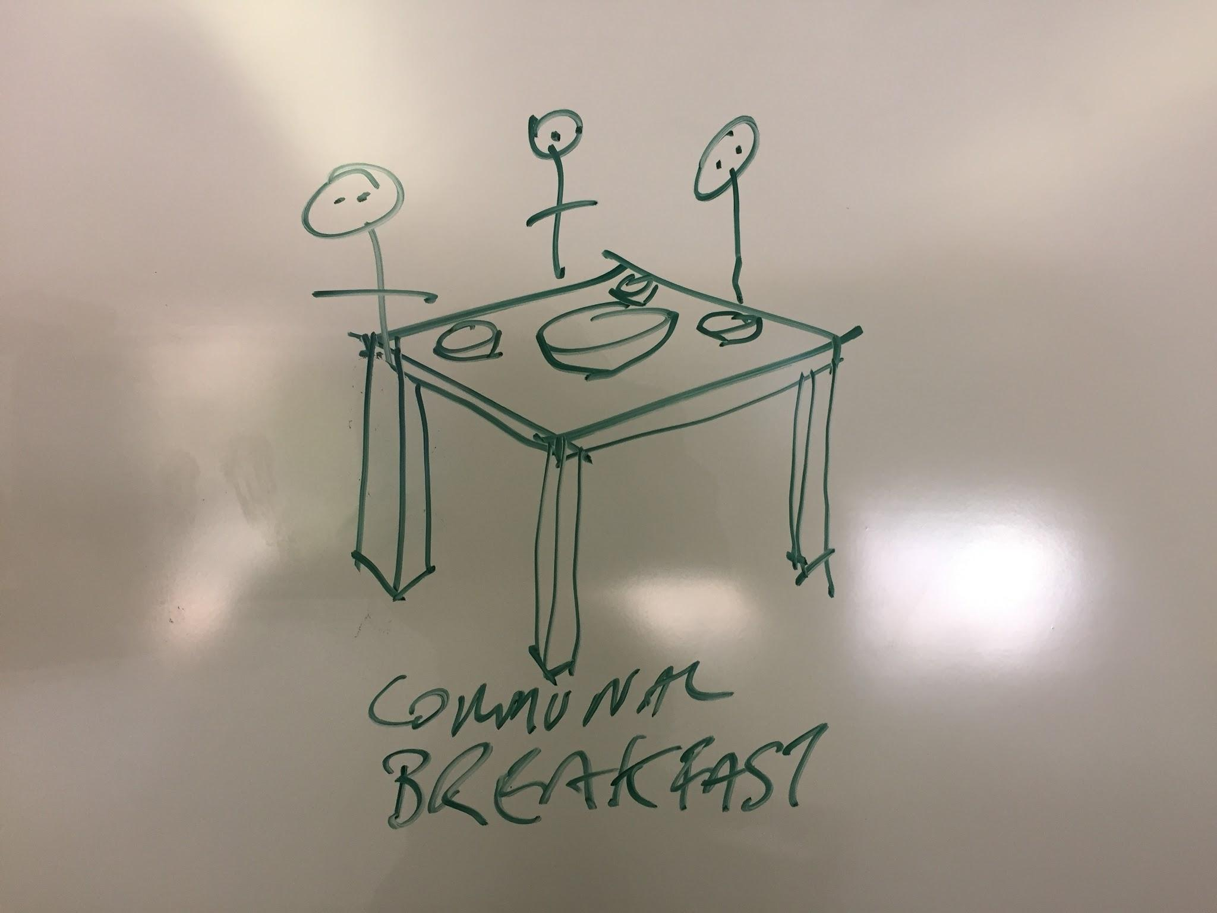
Afternoon
Evening

Growth Scenario
Futures Forces | Growth | What does the term mean in 2050? | What is a concrete example?
Population | Increasing
Energy | Sufficient
Economy | Dominant
Environment | Conquered
Culture | Dynamic
Technology | Accelerating
Governance | Corporate

Describe the context where your persona is situated in the scenario you are exploring in three or four bullet points:
- One
- Two
- Three
- Four

Step 2. Imagine a day in the life of your persona given the context you described above. Sketch, draw, storyboard, etc. Your goal is to communicate one day in the life of your persona mandala (please provide a link to the persona mandala here _________________.

Key frames from a day in the life of (add persona name) | Word description of activities | Sketch (paste in a stick figure sketch of the activities)
Morning | Example: Jane stops by the communal breakfast table and shares breakfast with her building neighbors. She is happy to chat with Sara. Bob eats quickly; he is sad and doesn’t want to talk to anyone.
Afternoon
Evening

Collapse Scenario
Futures Forces | Collapse | What does the term mean in 2050? | What is a concrete example?
Population | Declining
Energy | Scarce
Economy | Survival
Environment | Overshot
Culture | Stable
Technology | Limited
Governance | Local

Describe the context where your persona is situated in the scenario you are exploring in three or four bullet points:
- One
- Two
- Three
- Four

Step 2. Imagine a day in the life of your persona given the context you described above. Sketch, draw, storyboard, etc. Your goal is to communicate one day in the life of your persona mandala (please provide a link to the persona mandala here _________________.

Key frames from a day in the life of (add persona name) | Word description of activities | Sketch (paste in a stick figure sketch of the activities)
Morning | Example: Jane stops by the communal breakfast table and shares breakfast with her building neighbors. She is happy to chat with Sara. Bob eats quickly; he is sad and doesn’t want to talk to anyone.
Afternoon
Evening

Transform Scenario
Futures Forces | Transform | What does the term mean in 2050? | What is a concrete example?
Population | Limited
Energy | Abundant
Economy | Trivial
Environment | Artificial
Culture | Complex
Technology | Transformative
Governance | Direct

Describe the context where your persona is situated in the scenario you are exploring in three or four bullet points:
- One
- Two
- Three
- Four

Step 2. Imagine a day in the life of your persona given the context you described above. Sketch, draw, storyboard, etc. Your goal is to communicate one day in the life of your persona mandala (please provide a link to the persona mandala here _________________.

Key frames from a day in the life of (add persona name) | Word description of activities | Sketch (paste in a stick figure sketch of the activities)
Morning | Example: Jane stops by the communal breakfast table and shares breakfast with her building neighbors. She is happy to chat with Sara. Bob eats quickly; he is sad and doesn’t want to talk to anyone.
Afternoon
Evening

